YajHFC translation guide

General
To translate the application's messages, you will have to enter the translation into the attached .po files (messages_xy.po and CommandLineOpts_xy.po) and then send them back to me to integrate them into YajHFC.
I will then give you a developer version of YajHFC with the translation integrated to test your translation.
Shortly before the next release you will be contacted again to update the translation (usually this only involves translating 20-30 new messages that have been added in the meantime).

.po files
The easiest way to edit the po files is using a special editor like poedit (http://www.poedit.net/). You can also use a plain text editor if you wish, however (although I do not recommend this).
Editing the files should mostly be pretty self-explanatory for messages_xy.po (simply enter the translation of the "original string" (msgid) as "translation" (msgstr)).
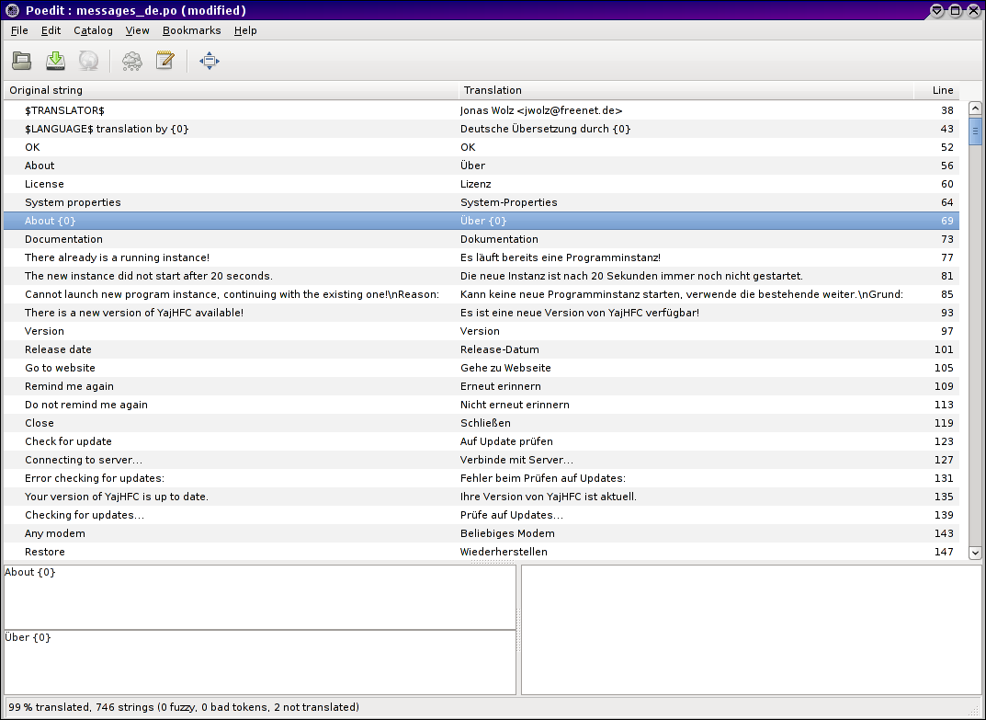
For CommandLineOpts_xy.po, the meaning of the original string is a bit different (please see About CommandLineOpts_pl.po below).

Things like {0} are place holders for numbers, file names or single words, so that these can appear at a different position in the translation (for example Displaying fax {0} is translated as Zeige Fax {0} an in German).

A special case is the date format (dd/MM/yyyy, HH:mm:ss). Here you should only change the order and the separator of the fields to represent the correct localized date format, but not the field names themselves (dd, MM, yyyy, ... should stay the same, but you can change their order and the separator (e.g. things like yyyy-MM-dd HH-mm-ss or dd.MM.yyyy HH:mm:ss are valid here); also see the screen shot below).
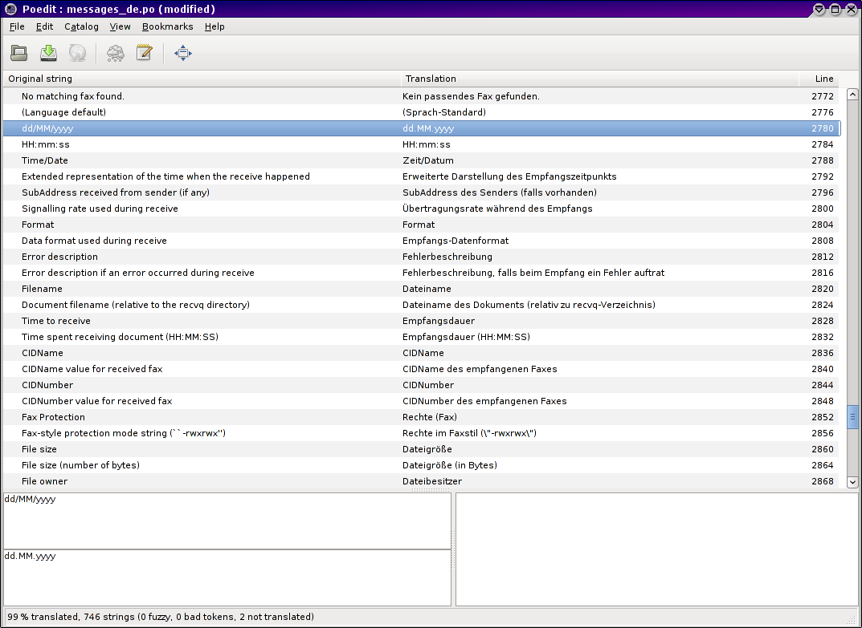
Another special case are the values $TRANSLATOR$ and $LANGUAGE$.
These can be replaced by your name and the translated name of your language and will show up in the about dialog as translation by... (see the first screen shot). If you don't change these values, nothing will show up there.

About CommandLineOpts_pl.po:
This file includes the descriptions for the command line options YajHFC supports (to localize the output of java -jar yajhfc.jar --help and the corresponding FAQ section).
The message "identifier" is not the full English text here, but the name of the long command line option with -desc appended (e.g. help-desc is the description of the --help parameter).
If the option takes an argument, there also is a message id with -arg appended, which is a single word giving a short description of the argument (e.g. help-arg is the description of the argument for the --help option).
Additionally, there are a few general entries which contain the translation of phrases like Usage or Argument description.
The English text is included in the comments for the messages. So, if you use poedit, it is probably a good idea to check View → Show comment window.

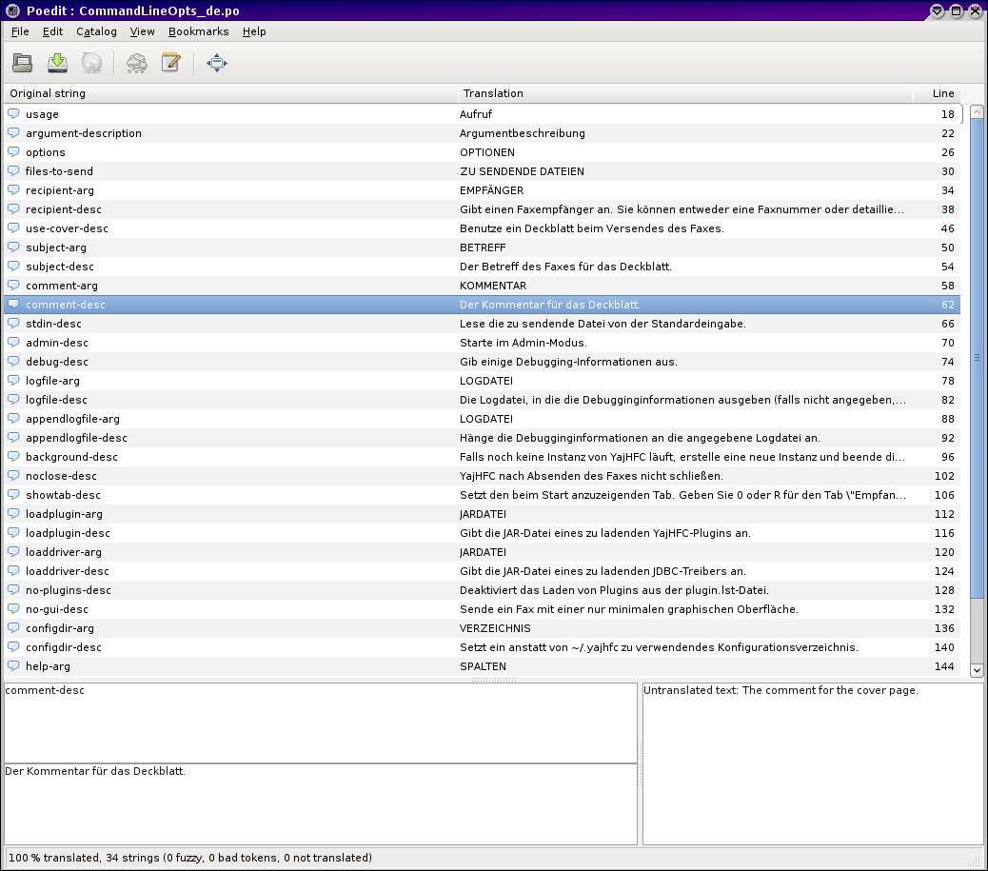
Example:
The output of YajHFC for the English locale will look like this:
Usage:
java -jar yajhfc.jar [OPTIONS]... [FILES TO SEND]...

Argument description:
-r, --recipient=RECIPIENT Specifies a recipient to send the fax to. You may
specify either a fax number or detailed cover page
information (see the FAQ for the format in the
latter case). You may specify --recipient multiple
times for multiple recipients.
-C, --use-cover[=yes|no] Use a cover page for sending a fax.
-s, --subject=SUBJECT The fax subject for the cover page.
--comment=COMMENT The comment for the cover page.
...

For English subject-arg is SUBJECT and subject-desc is The fax subject for the cover page..
Similarly, comment-arg is COMMENT and comment-desc is The comment for the cover page.. And so on...
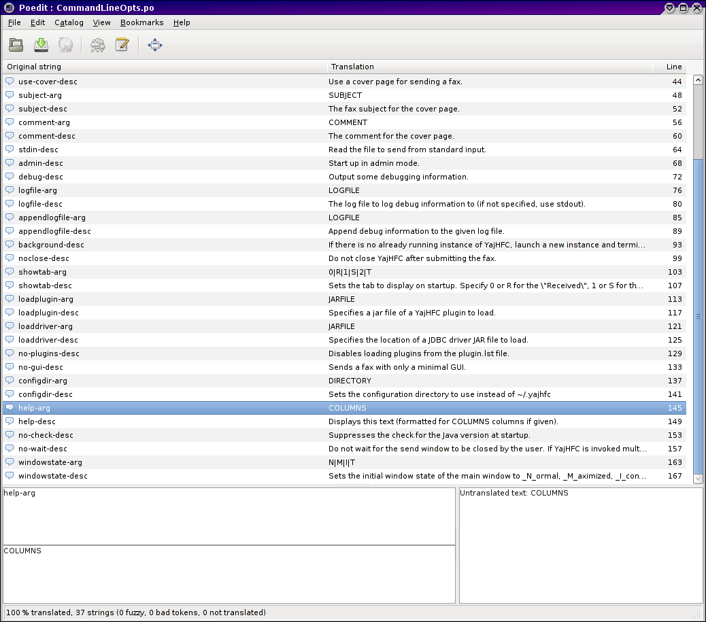
So, for the arg lines you should use a short form (preferably a single word), while the desc lines should contain a verbose description of what the parameter does.

FAQ and README
If you wish, you can optionally also translate the README and the source code of the FAQ (included in the subdirectory optional of the attached archive).
These are both plain text files and can be translated with a normal text editor (although syntax highlighting will help in case of the FAQ).

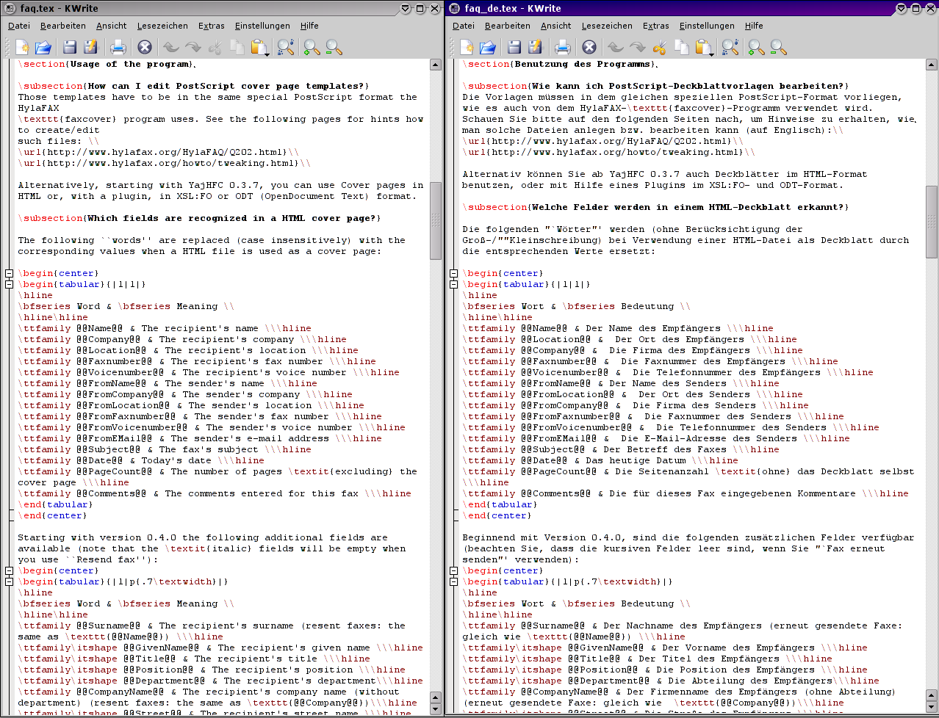
The .tex file for the FAQ is just a plain text document with commands embedded.
Commands start with a backslash (\). Stuff between [] are parameters to a command, stuff between {} is usually the text the command applies to.
So, when translating, as a rule of thumb, translate the parts that show up as english text in faq.pdf and leave the rest alone. Of course you can always ask if you are unsure.

